Could the Conservatives lose Westminster Council?

BY DAVE HILL
28th December 2017 Dave Hill Analysis 0
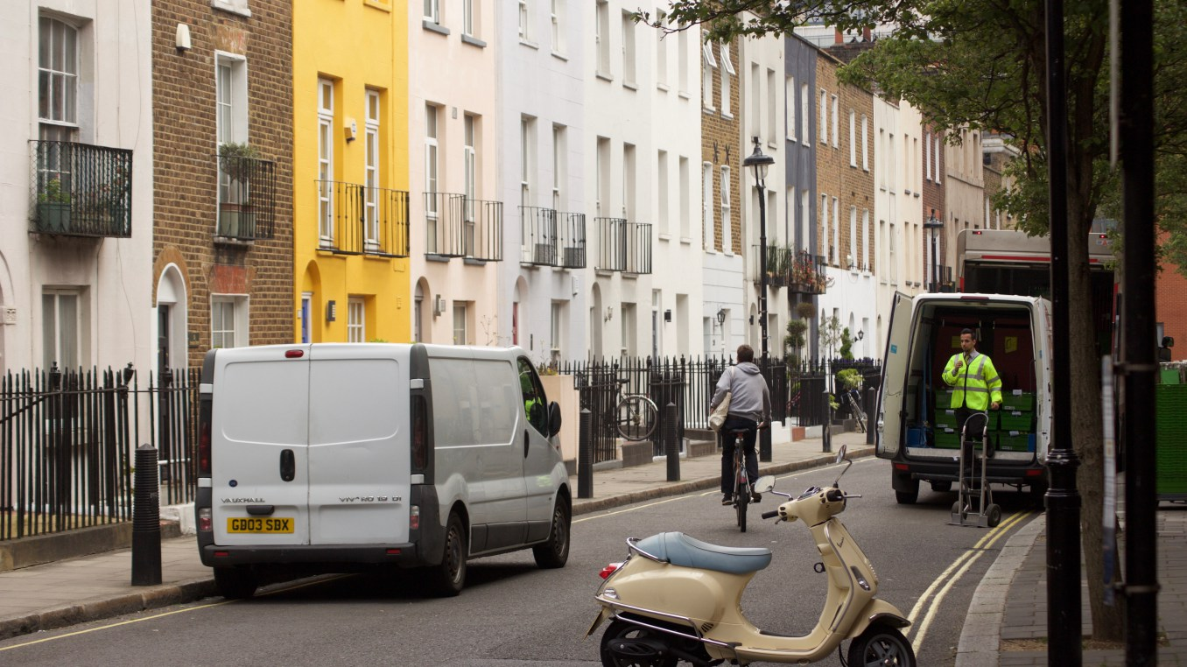

At State of Soho, local resident Andrew Murray asks: “Could Labour win Westminster Council?” This would have seemed a daft question as recently as May, but the general election results in Westminster’s parliamentary seats and subsequent scythings in the Tory undergrowth now make it worth asking – not least because Westminster Tories seem to be asking it themselves.
As Murray recounts, Westminster has been Conservative-run ever since it was invented, with Labour only really coming close to winning way back in 1986. Taking 16 seats out of 60 in 2014 was their best result since then, so a big change in fortunes would be required – Labour would need to almost double their present yield to pass the winning post of 31.
Is such a turnaround possible? Looking at the results from three-and-a-half years ago, Labour would need to overhaul margins of around 400 votes or more in a string of wards to pull off a sensational result. But on an optimistic view around a dozen seats could well be in play, and that’s enough to make Conservatives nervous.
Murray, who stood as an independent candidate last time round, detects “a significant and consistent upsurge in activity” by Labour, not only in his home ward of West End but “across the borough as a whole”. He also points to a number of developments during 2017 that might have shifted allegiances and concentrated minds: the Grenfell Tower fire in neighbouring Kensington and Chelsea and what that might mean for entrenched Tories nearby; the unfolding impacts of Brexit in this cosmopolitan borough; local activism across several wards stimulated by Sadiq Khan’s plans for the pedestrianisation of Oxford Street; residents’ concerns about intensive property development.
How any of these issues might affect voting patterns or turnouts in different and widely differing wards is hard to say, but Tory turbulence is clearly detectable. Labour sources say that Nickie Aitken, who succeeded Philippa Roe (now Baroness Couttie) as Westminster’s leader at the start of this year, has been a driving force behind moves to de-select sitting Tory councillors she thinks are past it. Such talk finds an echo in Twitter dispatches by a Baroness Westminster, who is not an Aitken fan (she calls her “Thickie”). Tart ripostes have come from one Duchess of Thorney.
It’s all frightfully immoderate. Watch this space for emerging details. Readers in the know are welcome to email davehillonlondon@gmail.com. Andrew Murray tweets here.
Share this:
Click to share on Twitter (Opens in new window)
Click to share on Facebook (Opens in new window)
Click to share on Google+ (Opens in new window)
Related
Election 2017: London's battleground

